727721EUCS035

HARINI M

DAY 7:

CE1:

INPUT:

**package** day7;

**import** org.openqa.selenium.WebDriver;

**import** org.openqa.selenium.chrome.ChromeDriver;

**import** org.openqa.selenium.chrome.ChromeOptions;

**import** org.testng.Assert;

**import** org.testng.annotations.Test;

**public** **class** d7project1 {

@Test

**public** **void** f() {

System.*setProperty*("webdriver.chrome.driver","C:\\chromedriver.exe");

ChromeOptions co=**new** ChromeOptions();

co.addArguments("--remote-allow-origins=*");

WebDriver driver=**new** ChromeDriver(co);

driver.get("https://demo.wpeverest.com/user-registration/guest-registration-form/");

String str=driver.getTitle();

System.***out***.println(str);

String expected="Guest Registration Form - User Registration";

Assert.*assertEquals*(str,expected);

}

}

OUTPUT:

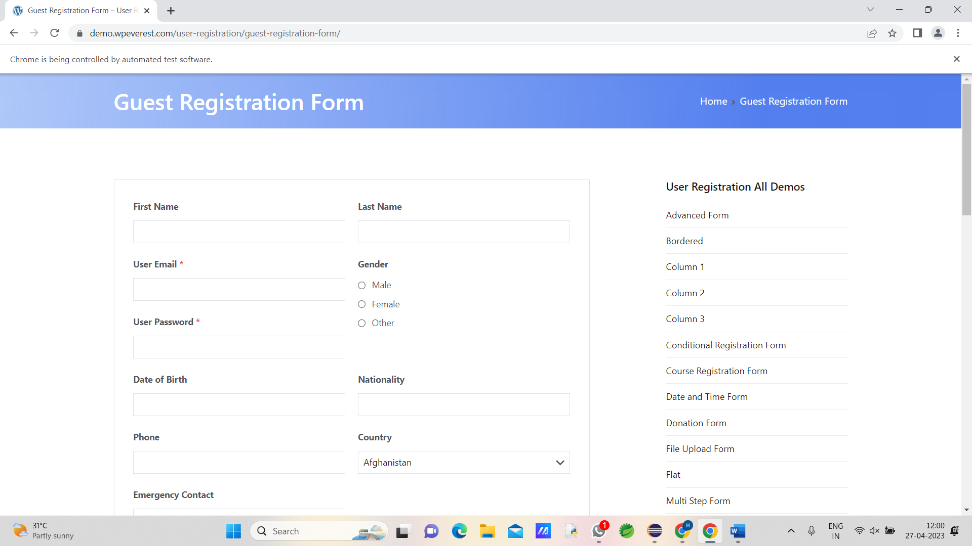

CE2:

INPUT:

**package** day7;

**import** java.util.Scanner;

**import** org.testng.Assert;

**import** org.testng.annotations.BeforeSuite;

**import** org.testng.annotations.BeforeTest;

**import** org.testng.annotations.Test;

**public** **class** d7project2 {

**int** a,b,c;

@BeforeTest

**void** getdata()

{

System.***out***.println("Enter the values to calculate:");

Scanner ob=**new** Scanner(System.***in***);

a=ob.nextInt();

b=ob.nextInt();

// a=7;

// b=4;

}

@Test

**public** **void** add() {

c=a+b;

Assert.*assertEquals*(c,11);

}

@Test

**public** **void** sub() {

c=a-b;

Assert.*assertEquals*(c,3);

}

@Test

**public** **void** mul() {

c=a*b;

Assert.*assertEquals*(c, 28);

}

@Test

**public** **void** divide() {

c=a/b;

Assert.*assertEquals*(c, 1);

}

}

OUTPUT:

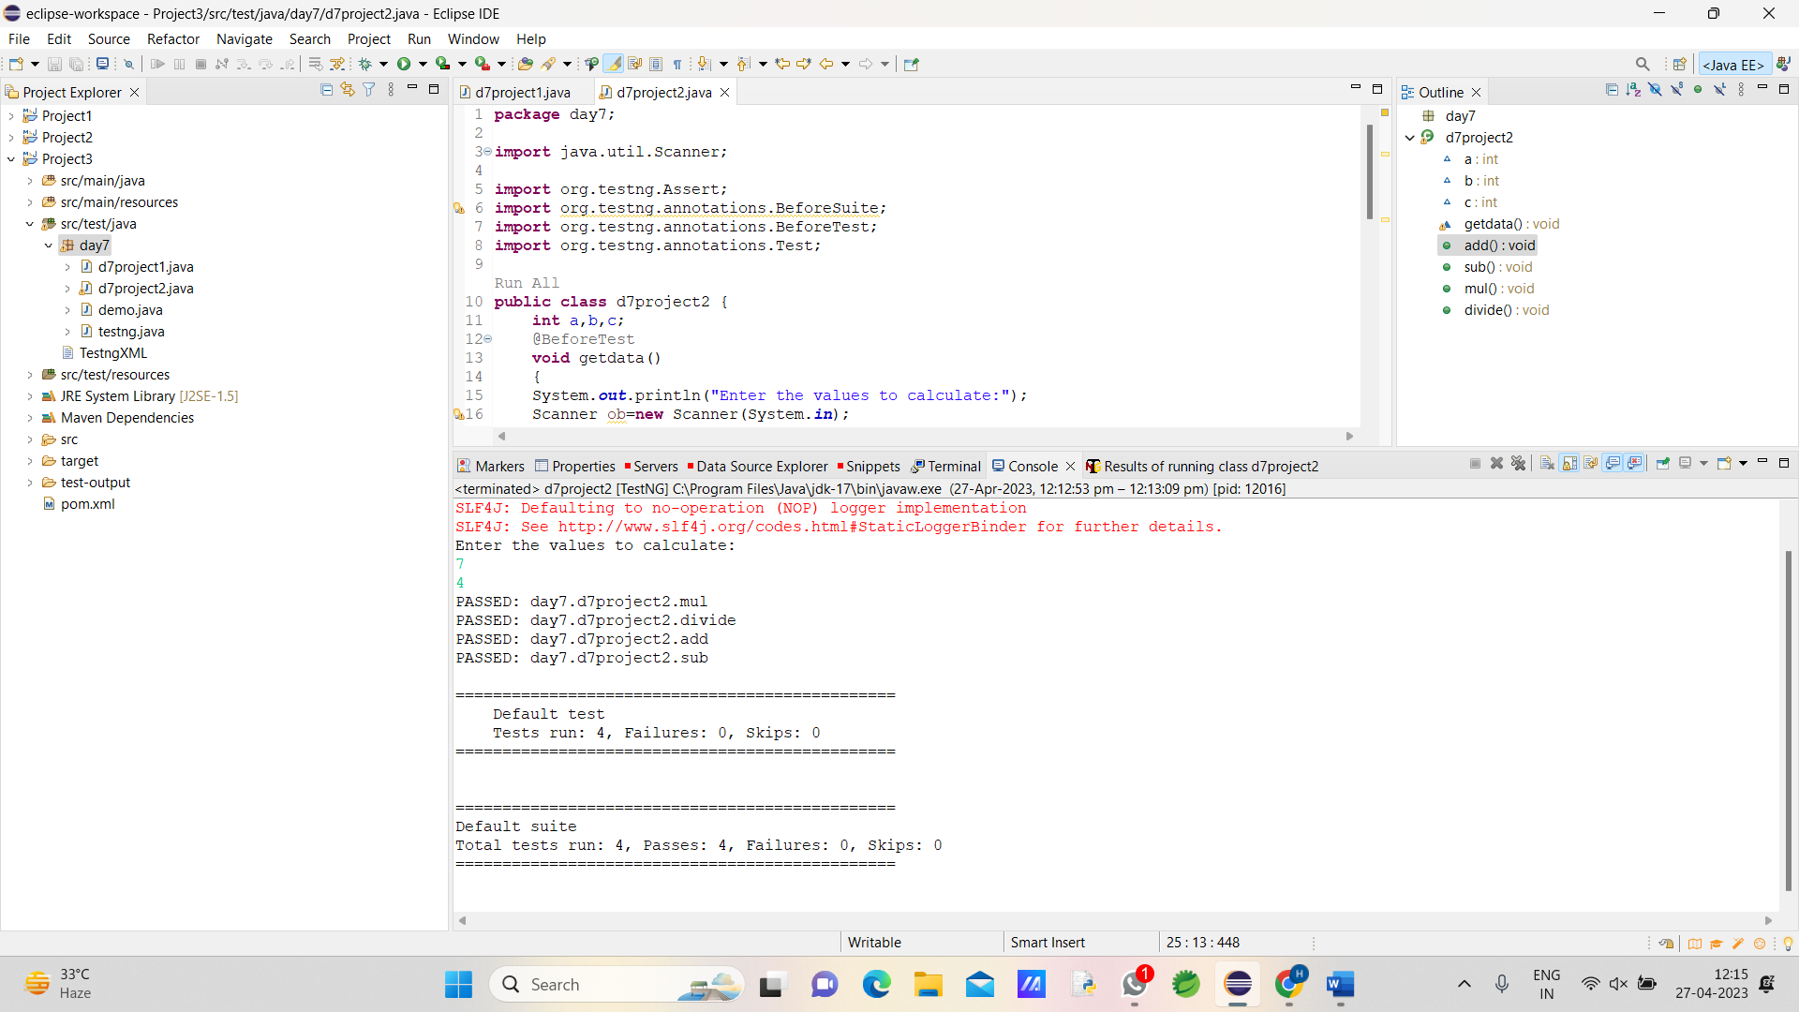

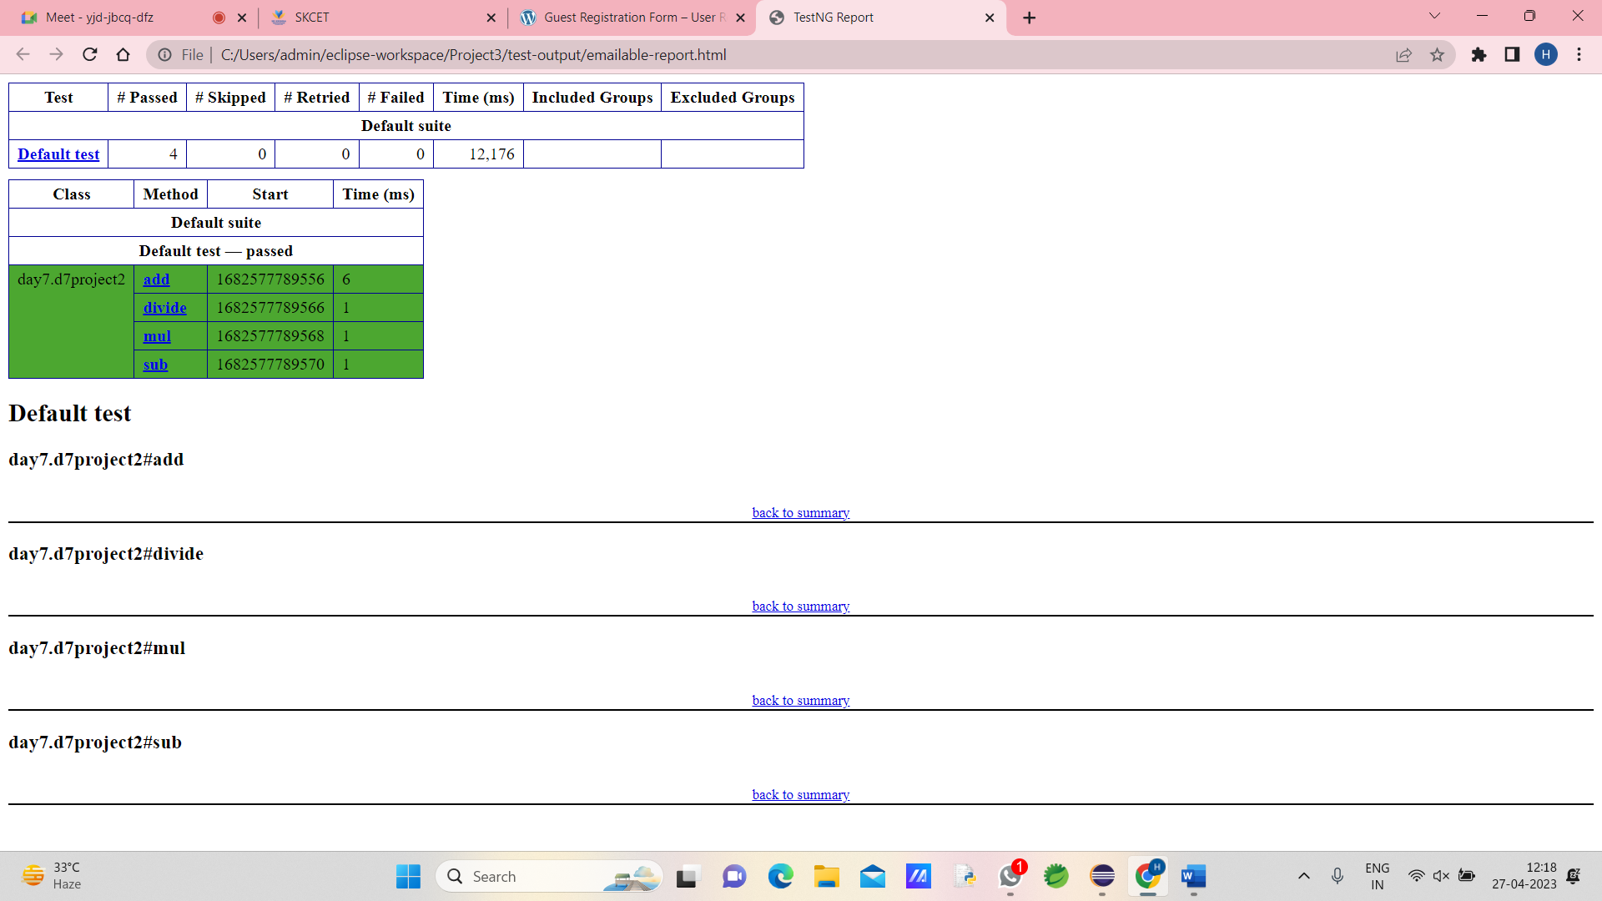

CE3:

INPUT:

**package** day7;

**import** org.testng.annotations.Test;

**import** io.github.bonigarcia.wdm.WebDriverManager;

**import** org.testng.annotations.BeforeMethod;

**import** org.testng.annotations.AfterMethod;

**import** org.openqa.selenium.By;

**import** org.openqa.selenium.WebDriver;

**import** org.openqa.selenium.WebElement;

**import** org.openqa.selenium.chrome.ChromeDriver;

**import** org.openqa.selenium.chrome.ChromeOptions;

**import** org.testng.Assert;

**public** **class** d7project3 {

WebDriver driver;

@Test

**public** **void** openURL() **throws** InterruptedException {

Thread.*sleep*(3000);

WebElement userName = driver.findElement(By.*name*("username"));

WebElement password = driver.findElement(By.*name*("password"));

WebElement submit = driver.findElement(By.*xpath*("//*[@class='oxd-button oxd-button--medium oxd-button--main orangehrm-login-button']"));

userName.sendKeys("Admin");

password.sendKeys("admin123");

submit.click();

Thread.*sleep*(3000);

String expectedURL = "https://opensource-demo.orangehrmlive.com/web/index.php/dashboard/index";

//String expectedURL = "https://opensource-demo.orangehrmlive.com/web/index.php/auth/login";

String actualURL = driver.getCurrentUrl();

Assert.*assertEquals*(expectedURL, actualURL);

}

@BeforeMethod

**public** **void** setup() {

//System.setProperty("webdriver.chrome.driver","C:\\Users\\tharu\\Downloads\\chromedriver_win32\\chromedriver.exe");

WebDriverManager.*chromedriver*().setup();

ChromeOptions co = **new** ChromeOptions();

co.addArguments("--remote-allow-origins=*");

driver = **new** ChromeDriver(co);

driver.manage().window().maximize();

String url = "https://opensource-demo.orangehrmlive.com/web/index.php/auth/login";

driver.get(url);

driver.manage().window().maximize();

}

@AfterMethod

**public** **void** teardown() {

driver.close();

}

}

OUTPUT:

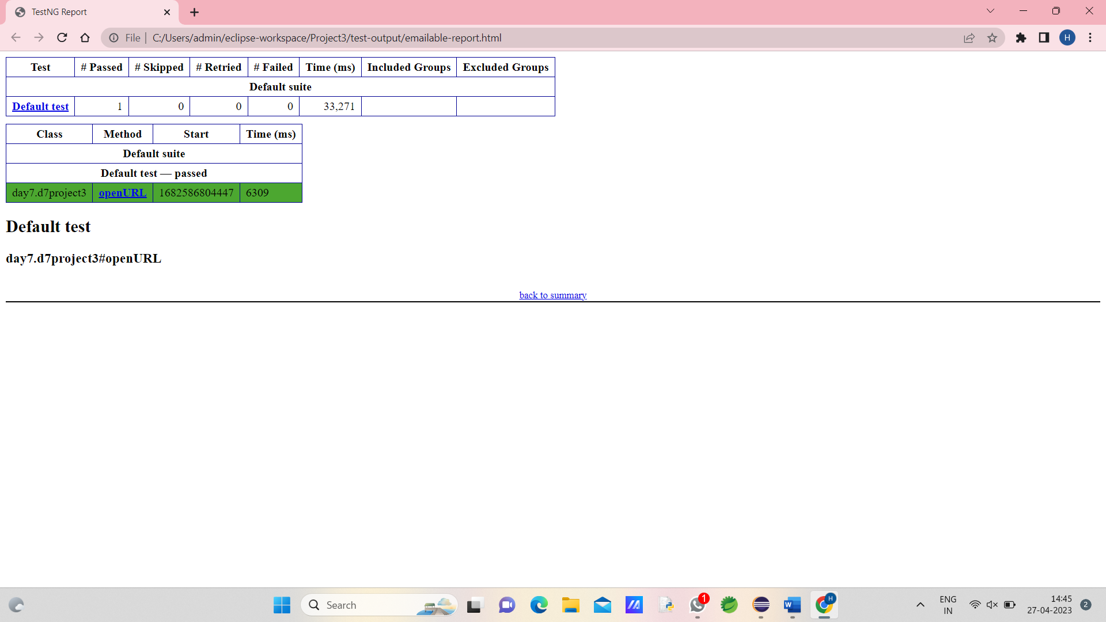

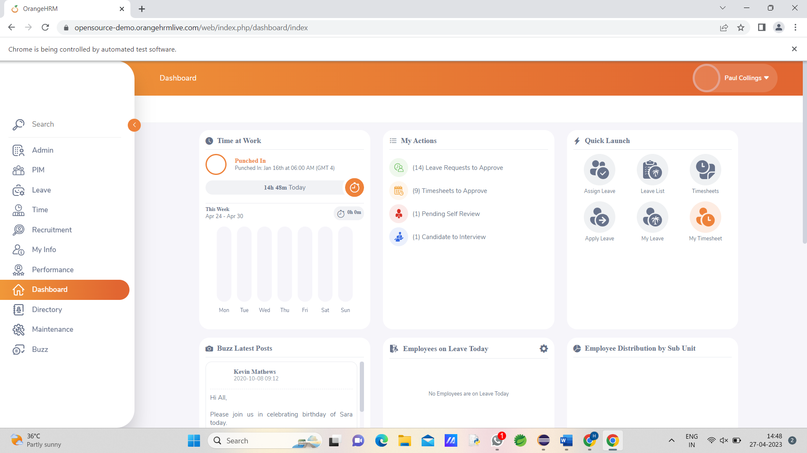

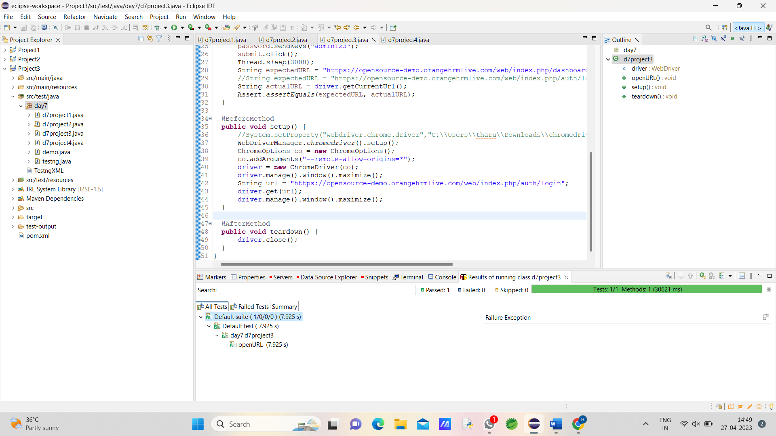

CE4:

INPUT:

package com.day7;

import org.openqa.selenium.By;

import org.openqa.selenium.WebDriver;

import org.openqa.selenium.WebElement;

import org.openqa.selenium.edge.EdgeDriver;

import org.openqa.selenium.edge.EdgeOptions;

import org.testng.Assert;

import org.testng.annotations.AfterMethod;

import org.testng.annotations.AfterSuite;

import org.testng.annotations.BeforeMethod;

import org.testng.annotations.BeforeSuite;

import org.testng.annotations.Test;

import io.github.bonigarcia.wdm.WebDriverManager;

public class Task4 {

static WebDriver driver;

@BeforeSuite

public static void Drive() {

EdgeOptions ed= new EdgeOptions();

driver=new EdgeDriver(ed);

}

@Test

public void dotsuff() {

driver.get("https://opensource-demo.orangehrmlive.com/web/index.php/auth/login");

driver.manage().window().maximize() ;

try {

Thread.sleep(3000);

} catch (InterruptedException e) {

e.printStackTrace();

}

WebElement uname=driver.findElement(By.name("username"));

WebElement pword=driver.findElement(By.name("password"));

WebElement submit=driver.findElement(By.xpath("//*[@id=\"app\"]/div[1]/div/div[1]/div/div[2]/div[2]/form/div[3]/button"));

uname.sendKeys("Admin");

pword.sendKeys("admin123");

submit.click();

String expecturl="https://opensource-demo.orangehrmlive.com/web/index.php/dashboard/index";

String curl=driver.getCurrentUrl();

Assert.assertEquals(expecturl, curl);

try {

Thread.sleep(5000);

} catch (InterruptedException e) {

// TODO Auto-generated catch block

e.printStackTrace();

}

}

@Test(dependsOnMethods = "dotsuff")

void distuff() throws InterruptedException {

WebElement profile=driver.findElement(By.className("oxd-userdropdown-name"));

profile.click();

try {

Thread.sleep(1000);

} catch (InterruptedException e) {

// TODO Auto-generated catch block

e.printStackTrace();

}

WebElement logout=driver.findElement(By.xpath("//*[@id=\"app\"]/div[1]/div[1]/header/div[1]/div[2]/ul/li/ul/li[4]/a"));

logout.click();

try {

Thread.sleep(3000);

} catch (InterruptedException e) {

e.printStackTrace();

}

String expecturl="https://opensource-demo.orangehrmlive.com/web/index.php/auth/login";

String curl=driver.getCurrentUrl();

Assert.assertEquals(expecturl, curl);

}

@AfterSuite

public void teardown() {

driver.close();

}

}

OUTPUT:

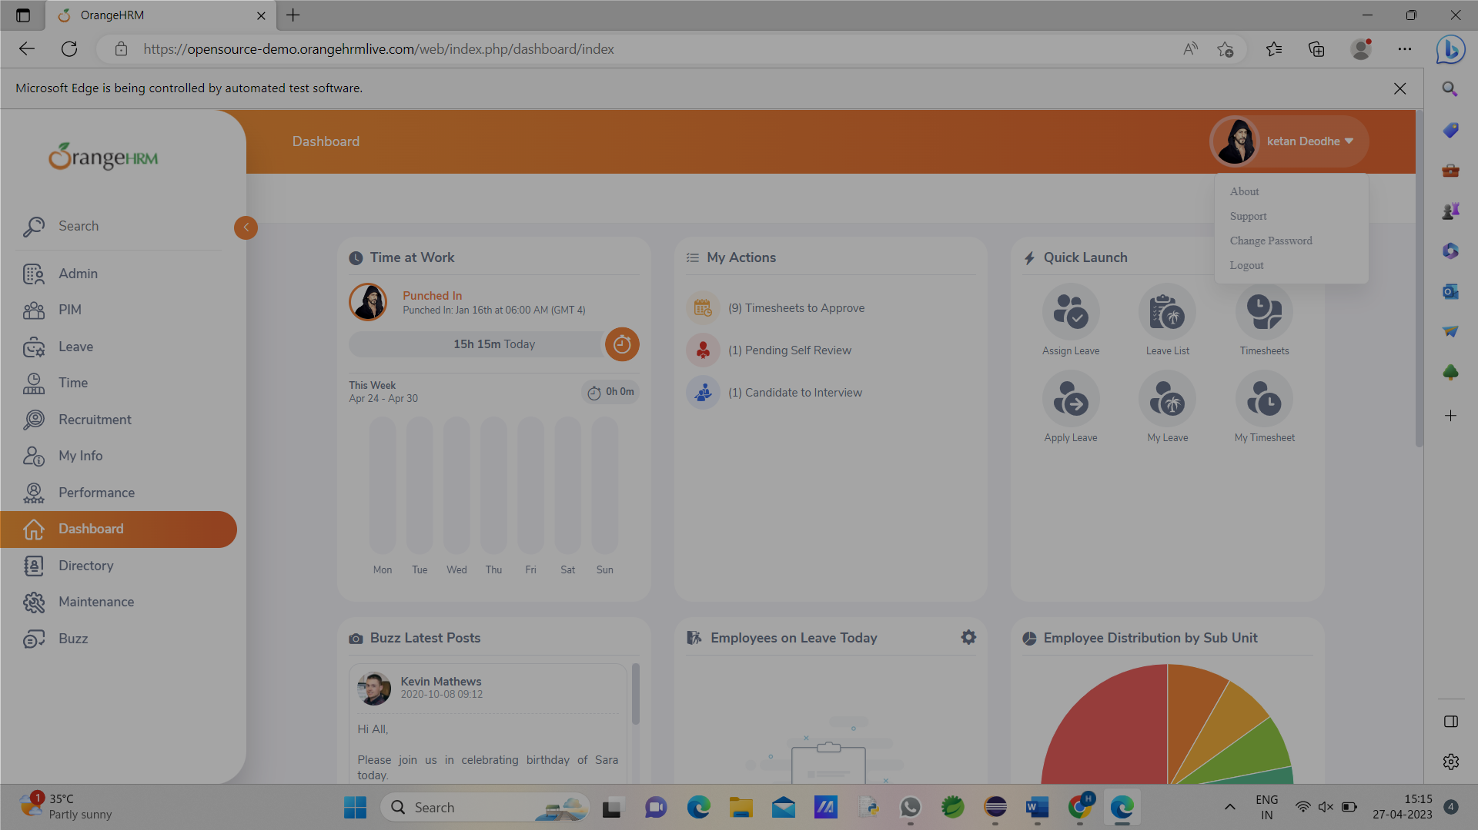

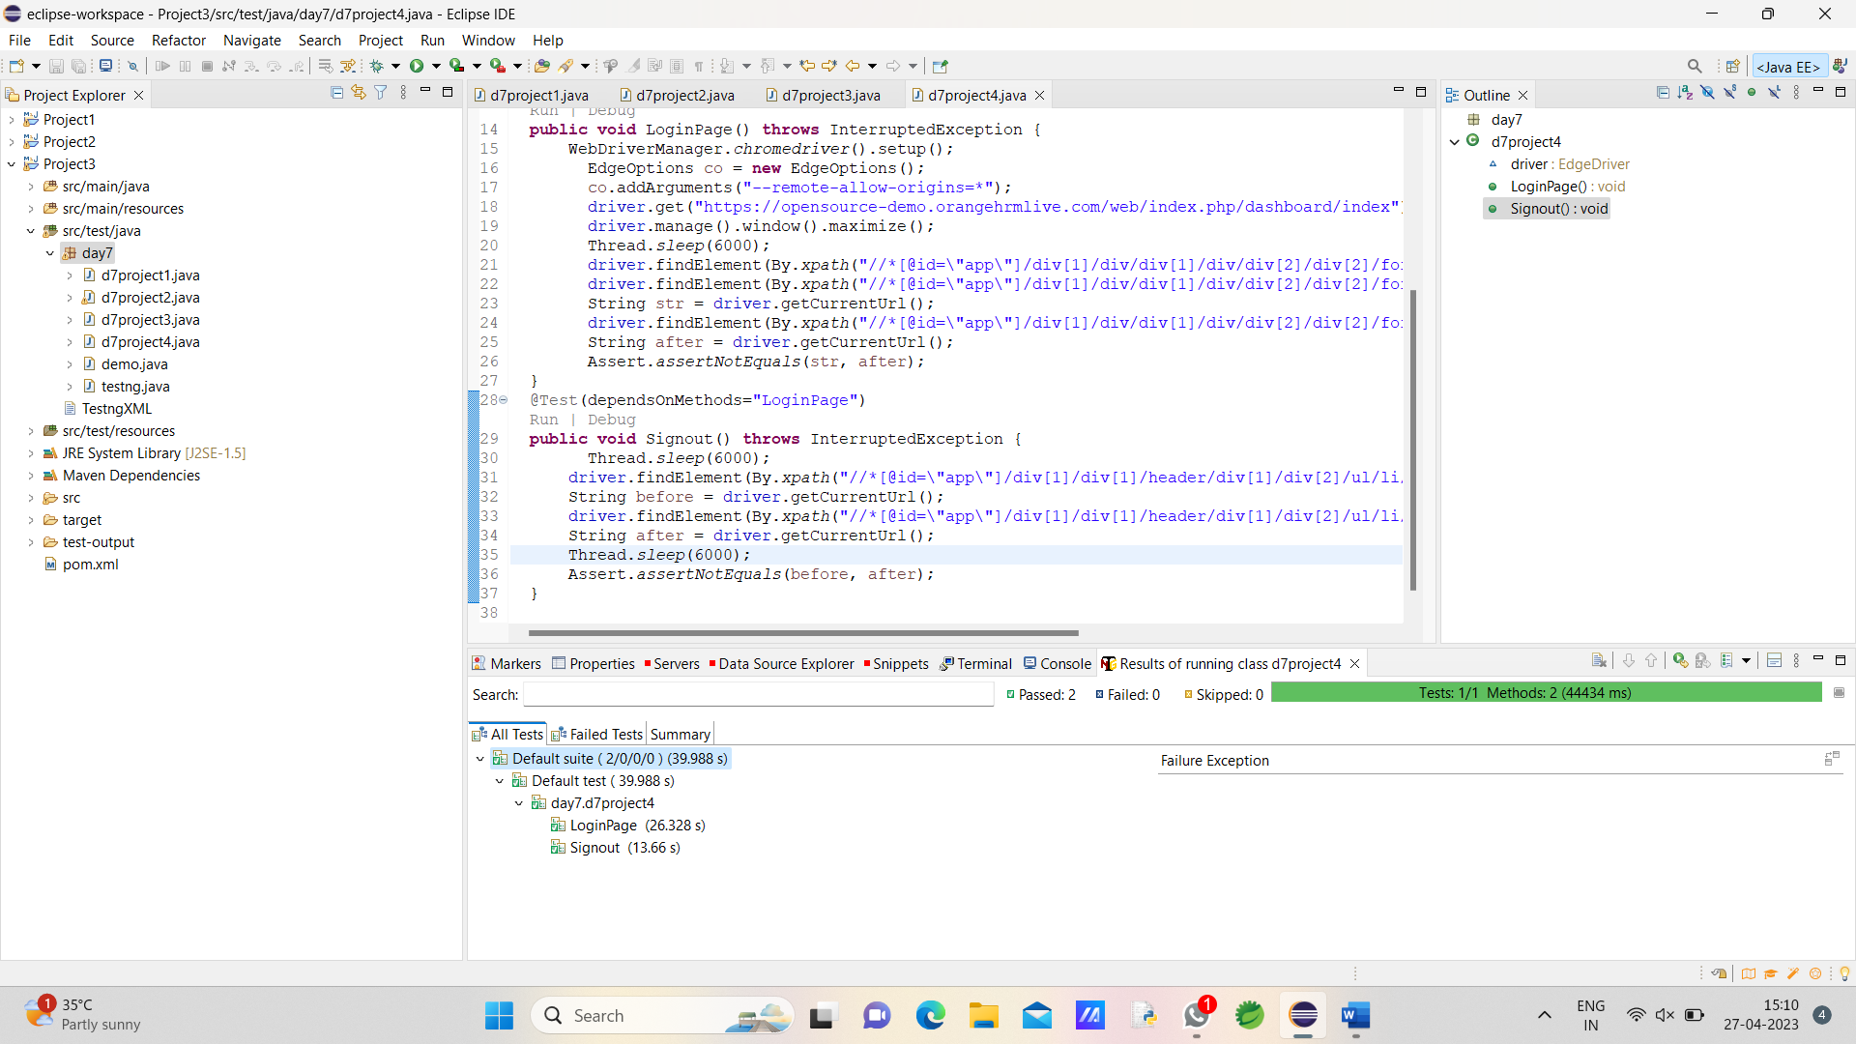

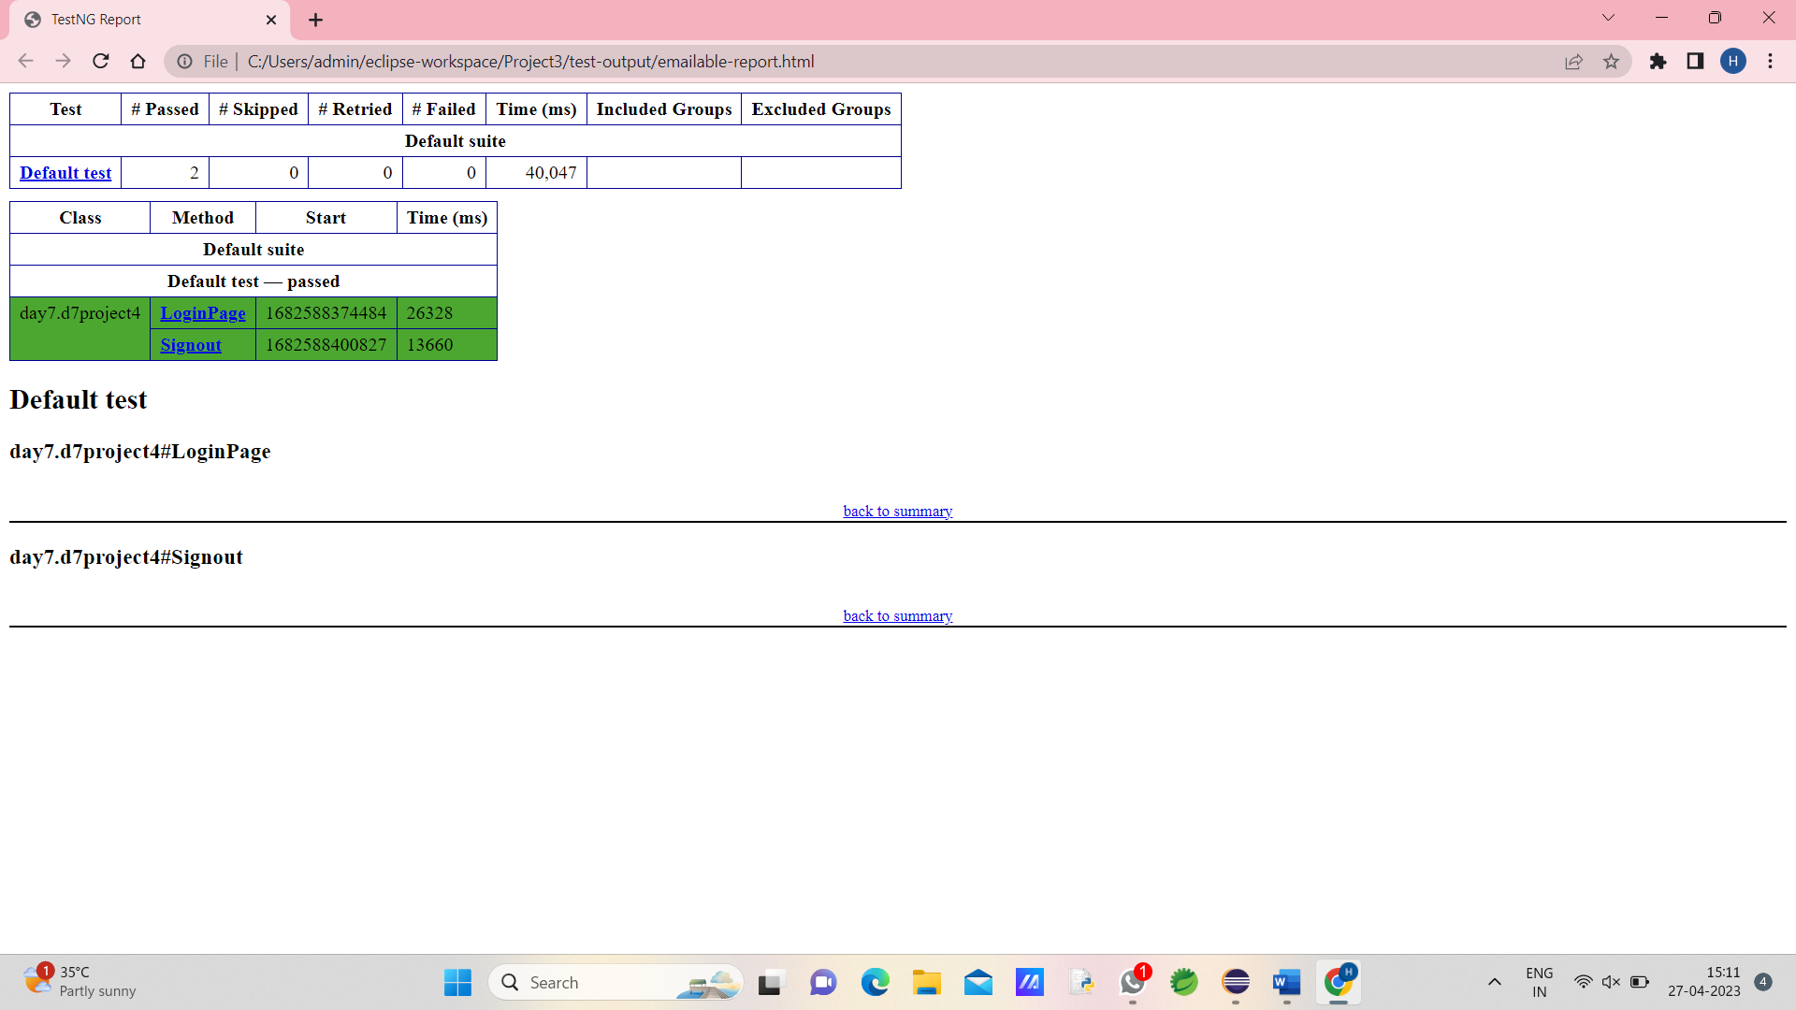

CE5

INPUT:

**package** day7;

**import** java.util.concurrent.TimeUnit;

**import** org.openqa.selenium.By;

**import** org.openqa.selenium.WebDriver;

**import** org.openqa.selenium.WebElement;

**import** org.openqa.selenium.chrome.ChromeDriver;

**import** org.openqa.selenium.chrome.ChromeOptions;

**import** org.testng.Assert;

**import** org.testng.annotations.BeforeSuite;

**import** org.testng.annotations.Test;

**import** io.github.bonigarcia.wdm.WebDriverManager;

**public** **class** d7project5 {

WebDriver driver;

// @BeforeSuite

//

// public void start(){

// WebDriverManager.chromedriver().setup();

// ChromeOptions co=new ChromeOptions();

// co.addArguments("--remote-allow-origins=*");

// driver=new ChromeDriver(co);

// }

@Test(groups="SmokeTest")

**public** **void** Test1() **throws** InterruptedException {

WebDriverManager.*chromedriver*().setup();

ChromeOptions co=**new** ChromeOptions();

co.addArguments("--remote-allow-origins=*");

driver=**new** ChromeDriver(co);

driver.get("https://www.godaddy.com/en-in");

driver.manage().window().maximize();

String actTit=driver.getTitle();

System.***out***.println(actTit);

String expTit="Domain Names, Websites, Hosting & Online Marketing Tools - GoDaddy IN";

Assert.*assertEquals*(actTit,expTit);

Thread.*sleep*(1500);

driver.close();

}

@Test(groups="RegressionTest")

**public** **void** Test2() **throws** InterruptedException {

// WebDriverManager.chromedriver().setup();

ChromeOptions co=**new** ChromeOptions();

co.addArguments("--remote-allow-origins=*");

driver=**new** ChromeDriver(co);

driver.get("https://www.godaddy.com/en-in");

driver.manage().window().maximize();

driver.manage().timeouts().~~implicitlyWait~~(1000,TimeUnit.***MILLISECONDS***);

WebElement c1=driver.findElement(By.*xpath*("//*[@id=\"id-631b049a-e9c0-4d24-8710-c504745206dd\"]/button"));

c1.click();

Thread.*sleep*(1000);

WebElement c2=driver.findElement(By.*xpath*("//*[@id=\"id-631b049a-e9c0-4d24-8710-c504745206dd\"]/div[2]/div[1]/ul/li[1]"));

c2.click();

Thread.*sleep*(1000);

WebElement c3=driver.findElement(By.*xpath*("//*[@id=\"id-631b049a-e9c0-4d24-8710-c504745206dd\"]/div[2]/div[1]/ul/li[1]/div/div[2]/div[1]/ul/li[2]/a"));

c3.click();

Thread.*sleep*(1000);

driver.close();

}

@Test(groups="RegressionTest")

**public** **void** Test3() **throws** InterruptedException {

// WebDriverManager.chromedriver().setup();

ChromeOptions co=**new** ChromeOptions();

co.addArguments("--remote-allow-origins=*");

driver=**new** ChromeDriver(co);

driver.get("https://www.godaddy.com/en-in");

driver.manage().window().maximize();

driver.manage().timeouts().~~implicitlyWait~~(1000,TimeUnit.***MILLISECONDS***);

Thread.*sleep*(1000);

WebElement c1=driver.findElement(By.*xpath*("//*[@id=\"id-631b049a-e9c0-4d24-8710-c504745206dd\"]/button"));

c1.click();

Thread.*sleep*(1000);

WebElement c2=driver.findElement(By.*xpath*("//*[@id=\"id-631b049a-e9c0-4d24-8710-c504745206dd\"]/div[2]/div[1]/ul/li[1]"));

c2.click();

Thread.*sleep*(1000);

WebElement c3=driver.findElement(By.*xpath*("//*[@id=\"id-631b049a-e9c0-4d24-8710-c504745206dd\"]/div[2]/div[1]/ul/li[1]/div/div[2]/div[1]/ul/li[2]/a"));

c3.click();

Thread.*sleep*(2000);

String x=driver.getTitle();

System.***out***.println(x);

}

}

OUTPUT:

